Assignment 11

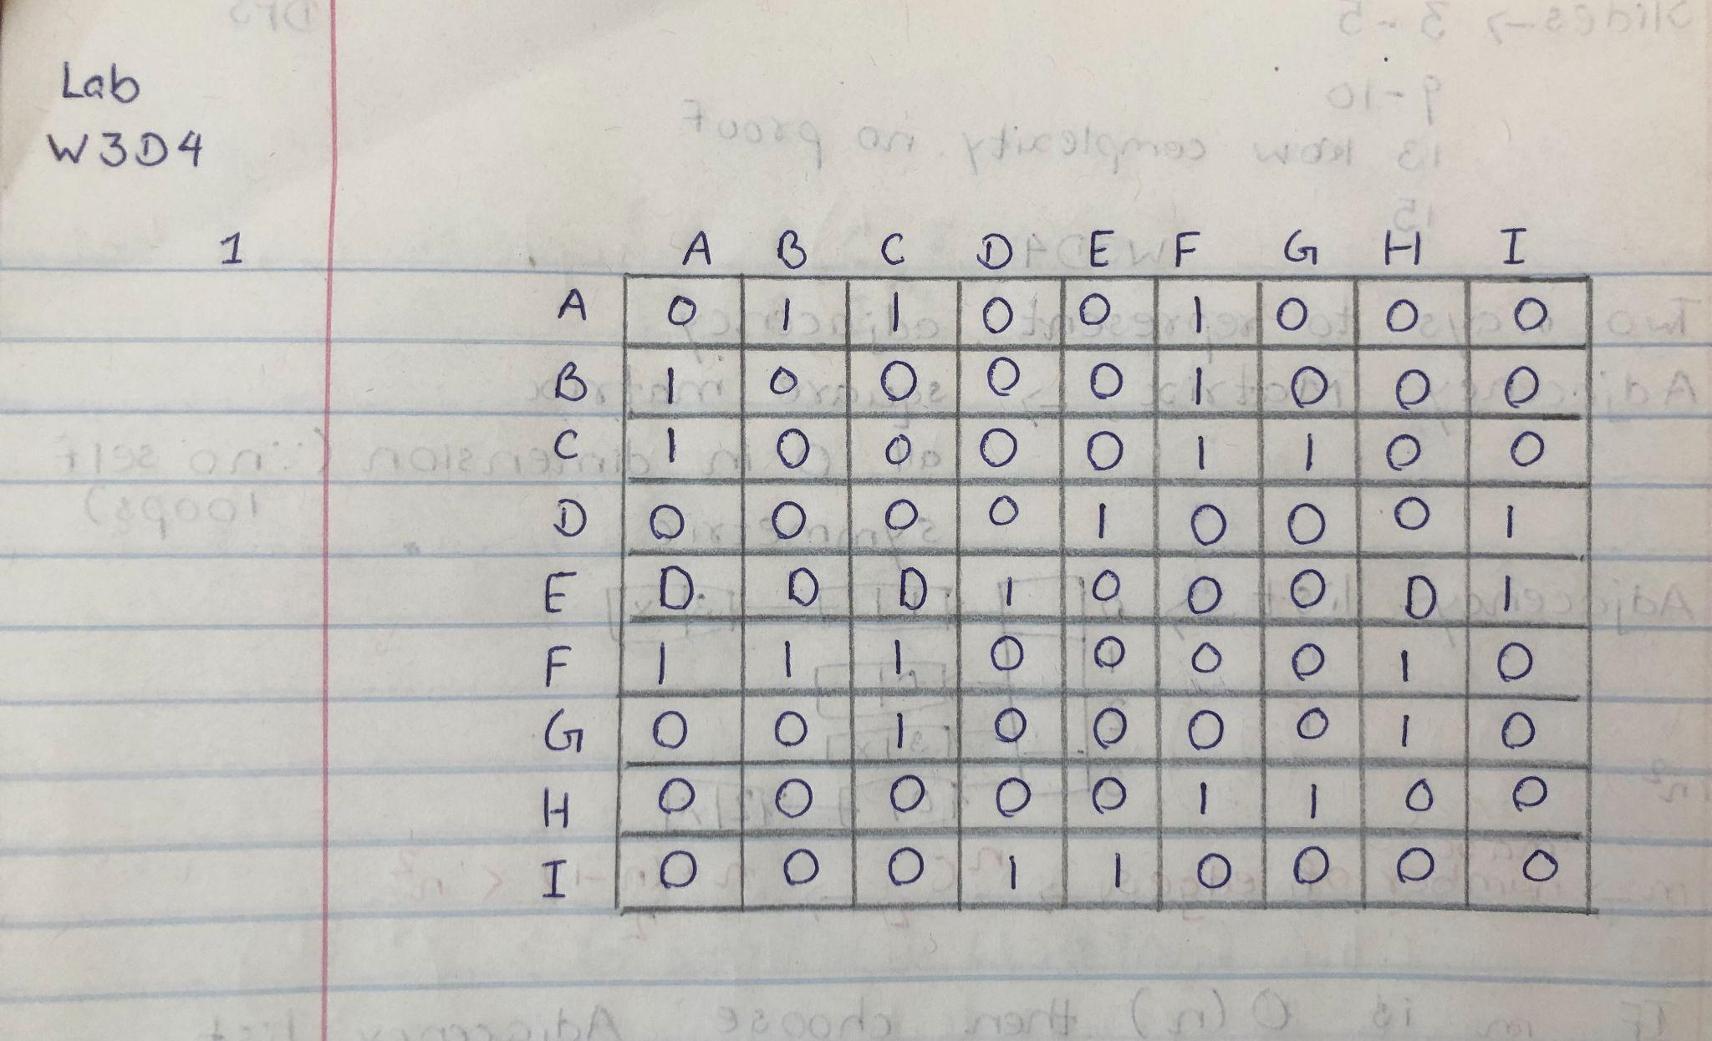

2 and 3 are in java files.